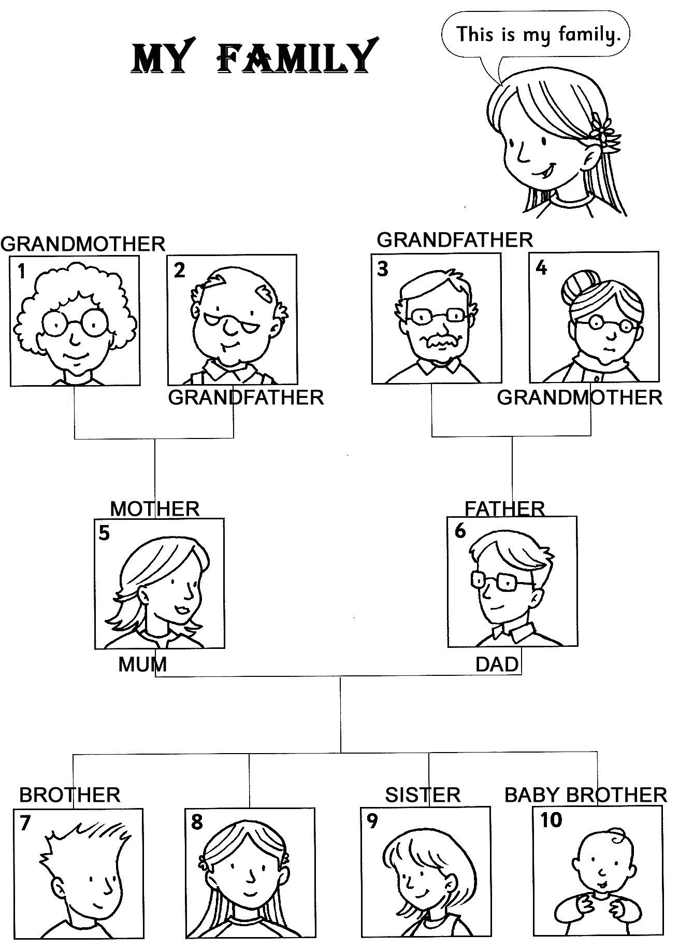

SCRIVI I TERMINI CORRISPONDENTI NELLE CASELLE: BROTHER, MOTHER, SISTER, GRANDFATHER, FATHER, BABY BROTHER, GRANDMOTHER, MUM, DAD

